Congratulations - you are moments away from being part of our Hoopers Workshop. Places are limited and accepted on a first paid, first start basis.
Before paying please ensure we still have spaces available.
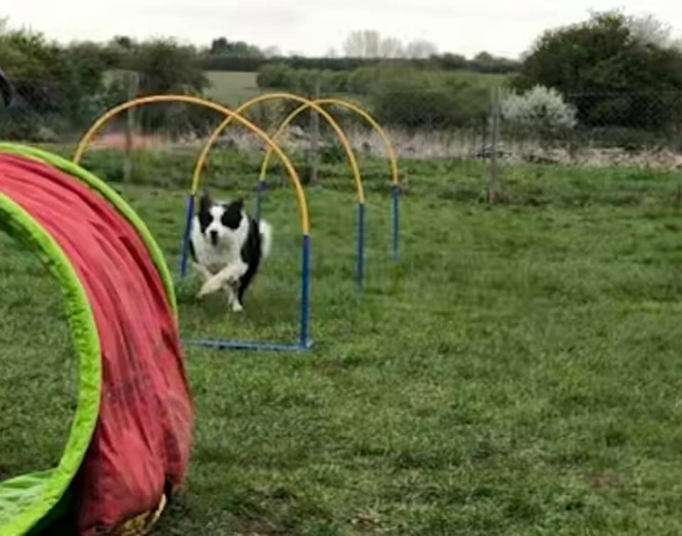
How to find us - We are based at Newbarn Farm (NN9 6HY) which is a small industrial estate off Brick Kiln Road in Raunds. As you go down Brick Kiln Road from the roundabout, the entrance is on your left-hand side and has a remote-controlled gate. If this is closed please ring my mobile 3 times (07749 285330) and I will open it for you. Follow the road to the very top until you see Coggins Garage, turn right and drive along past the industrial units. On the left (past the boat) you will see a field, we are in there. You are welcome to park in the field, please do not block anyone in as members come and go all the time. If it is wet, we advise parking on the hard-standing before the field entrance. Come and say Hi, we’re a friendly bunch
We use kind, reward-based training methods at BUDS and will not tolerate harsh handling or raised voices. Our aim is to help you to achieve your goals by rewarding what is right and ignoring what is wrong. Dogs soon learn that good things happen when they make the right choices.
The Workshop costs £20.00 for the 2 hours which is payable prior to the start date via online payment to:
- Account Name: Bordertrix Ultimate Dog School
- Sort Code: 20-0573
- Account Number: 63939154
Please use the first 3 letters of your dog’s name and your surname so I can ensure I can match the online payments to the correct dog. Places are not guaranteed until payment is received.
Below we have included the information you need to ensure you get the very most out of your time with us.
Important - This workshop is open to all dogs aged 6 months and over. We reserve the right to refuse training if we feel your dog is not suitable due to fitness/temperament issues.
- Treats and toys – we use both at BUDS because by reinforcing happy association with training means your dog will want to work with you. I use cooked sausages, ham or any cold, cooked meat. Cheese is also good but can upset sensitive tummies, or simply save some meat from your Sunday roast. The tastier the treat the more your dog will want to train.
- Toys that can be thrown are the best. If your dog is easily distracted, we suggest using a squeaky toy to help keep their focus.
- A secure fitting collar is essential, you should only be able to fit 2 fingers between a collar and the dog’s neck. Any more than this could result in your dog slipping his collar - you really do not want that to happen.
- Your dog should legally have an identification disk on its collar, this is a legal requirement and a microchip does not replace the need for it. This should legally have your name and your address on it but I recommend also your home and/or mobile telephone number, Vet’s telephone number, “I’m chipped”, but definitely NOT your dog’s name.
- Please bring poo bags, you will be expected to clear up any faeces and disinfect any equipment that has been weed on. To avoid this as much as possible you are welcome to walk your dog around the perimeter of the main field, so they arrive ready and not needing to toilet. Ensure you are ready to start your Class on time. We do supply water for the dogs, however, when it is really hot, we recommend ensuring you have some available. There is an outside tap nearby.
- Make sure you are wearing suitable footwear - for a field. Trainers are probably the best unless it has been raining. Wellies and boots cover most eventualities but ensure you will be able to move around freely with your dog.
- Because we all need a starting point it would be helpful if you could practice sitting and waiting with your dog before you come for training. If you are struggling, don’t worry, you won’t be alone.

*In brief:
- Pay £20.00 for the Workshop (Account Name: Bordertrix Ultimate Dog School, Sort Code: 20-05-73, Account Number: 63939154)
- Write the date on your calendar
- Get some tasty treats (sausage is best)!
- Your dog’s favourite toys,
- Collar with identification disk
- Lead
- Poo bags
- Water
- Trainers/wellies
*This is just an advisory list and does not mean owners will not be able to take part if all points are not covered.

